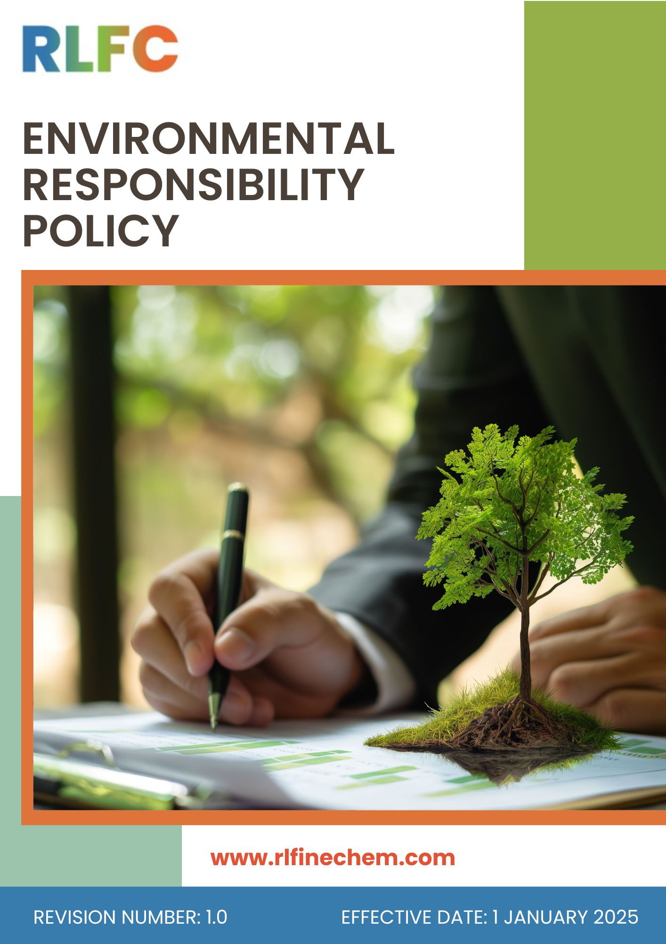
Environmental Responsibility Policy
Document No: DOC.RLF.POL.01
Effective Date: 1st January 2025
Last Review Date:1st January 2026
Next Review Date: 1st January 2027
Revision No: 1.0

Objective
The objective of this Environmental Responsibility Policy is to establish a structured framework for managing environmental aspects arising from the operations, products, and services of R L Fine Chem Pvt. Ltd. The Company is committed to minimizing its environmental footprint, preventing pollution, conserving natural resources, enhancing resource efficiency, and complying with all applicable environmental laws and regulations.
Through this Policy, RLFC aims to:
- Promote sustainable manufacturing practices across all facilities and operations.
- Reduce energy consumption and greenhouse gas emissions.
- Optimize water use and protect water resources.
- Prevent air, water, and soil pollution.
- Ensure environmentally sound management of chemicals, materials, and waste.
- Foster a culture of environmental awareness and accountability among employees, contractors, suppliers, and business partners.

Scope
This Policy applies to all operations of R L Fine Chem Pvt. Ltd., including its Registered Office, Corporate Office, Manufacturing Plants, laboratories and all associated business activities. It covers all permanent, temporary, and contract employees across all functions, as well as suppliers, contractors, service providers, and other stakeholders directly or indirectly associated with the Company.
Sr. No | Office / Plant | Address
1 | R L Fine Chem Pvt. Ltd (REFEX) – Head Office | Phoenix Mall of Asia – Tower 2, Level 6, Unit 602, Yelahanka Hobli, Byatarayanapura, Bangalore – 560092.
2 | R&D Centre | RLFC House, C-10, Ist Cross, KSSIDC, Industrial Estate Yelahanka New Town Bengaluru - 560 064 Karnataka, India
3 | Hindupur Plant | M/s RL FINE CHEM PRIVATE LIMITED  Plot No.165–182, APIIC Growth Centre, Thumakunta, Hindupur – 515 211, Sri Sathya Sai District, Andhra Pradesh, India
4 | Gauribidanur Plant | R L Fine Chem Pvt. Ltd.  Plot No IP-27-29, KIADB Industrial Area Ist Phase, Kudumalakunte Village Gauribidanur, Chikkaballapur Distt Karnataka - 561208

Definitions
- Environment: The natural and surrounding conditions, including air, water, land, ecosystems, biodiversity, and communities affected by RLFC's operations.
- Environmental Impact: Any positive or negative change to the environment resulting from RLFC's activities, products, or services.
- Sustainability: Conducting business responsibly by balancing environmental, social, and economic considerations for long-term value creation.
- Energy Consumption: The use of electricity, fuel, and other energy sources in operational and business activities.
- Greenhouse Gas (GHG) Emissions: Emissions of gases such as CO₂, CH₄, and N₂O that contribute to climate change.
- Water Stewardship: The responsible use, conservation, treatment, and management of water resources.
- Biodiversity: The variety of living organisms and ecosystems that may be influenced by RLFC's operations.
- Air Pollution: The release of pollutants, emissions, dust, or fumes into the atmosphere that may affect environmental quality and health.
- Waste: Materials or by-products generated from operations that require disposal, recycling, recovery, or reuse.
- Product Stewardship: Managing environmental, health, and safety impacts of products throughout their life cycle.

Roles and Responsibilities
- Top Management
- Demonstrates leadership commitment toward environmental protection and sustainability integration into business strategy and operations.
- Ensures availability of adequate resources, including financial, human, and technological support, for effective implementation of environmental objectives.
- Reviews environmental performance periodically to ensure continuous improvement and effectiveness of the Environmental Management System (EMS).
- Ensures compliance with applicable environmental laws, regulations, and other obligations.
- Promotes a culture of environmental responsibility across all levels of the organization.
- Review this Policy periodically.
- EHS Head
- Develops, implements, and maintains the Environmental Management System in alignment with applicable standards and regulatory requirements.
- Monitors environmental performance indicators and submits periodic reports to top management.
- Ensures identification, tracking, and compliance with applicable legal and other environmental requirements.
- Coordinates internal audits, inspections, and follow-up of corrective and preventive actions.
- Facilitates environmental risk assessments and ensures implementation of mitigation measures.
- Department Heads
- Ensures implementation of environmental procedures and compliance within respective departments.
- Identifies opportunities for resource efficiency, pollution prevention, and waste minimization.
- Ensures employees adherence to environmental guidelines and good housekeeping practices.
- Supports execution of environmental initiatives, targets, and corrective actions.
- Monitors departmental environmental performance and addresses deviations promptly.
- Employees
- Compliance with environmental policies, procedures, and operational controls during daily activities.
- Responsible use of resources including water, energy, and raw materials to prevent wastage.
- Participation in environmental awareness, training programs, and improvement initiatives.
- Prompt reporting of spills, leaks, non-conformities, or environmental incidents.
- Contribution to pollution prevention and sustainability improvement efforts.
- Contractors & Suppliers
- Compliance with applicable environmental requirements while working on company premises or projects.
- Adherence to safe handling, storage, transportation, and disposal practices for materials and waste.
- Implementation of environmentally responsible practices aligned with company expectations.
- Cooperation during inspections, audits, and monitoring activities.
- Immediate reporting of environmental incidents or non-compliances to authorized personnel.

Environmental Objectives and Targets
We will actively seek to prevent pollution before it is produced and to minimize the impact on the environment by establishing environmental objectives and targets aimed at improving our overall environmental performance. We will consider environmental factors when we plan, purchase, or make operating decisions.
- Water Stewardship
- We will optimize water consumption through efficient operational practices and regular monitoring.
- We aim to increase water reuse and recycling by enhancing water recovery systems.
- We strive to improve water-use efficiency by adopting water-saving technologies and processes.
- We are committed to protecting water resources through effective wastewater treatment and responsible discharge practices.
- We seek to prevent water losses by implementing routine inspections and timely maintenance of water infrastructure.
- We will foster responsible water-use behavior through employee awareness and engagement programs.
- We will explore rainwater harvesting and water replenishment opportunities to support long-term water security.
- We aim to strengthen water governance through data-driven monitoring, tracking water performance indicators, reporting and continual improvement initiatives.
Targets
Baseline Year: FY 2022-23 | Target Year: FY 2029-30
- We will reduce freshwater withdrawal intensity by 10% through water conservation and process optimization initiatives.
- We aim to increase the proportion of water recycled and reused in operations to 15% of total water consumption.
- We strive to reduce process-related water consumption intensity by 25% through operational efficiency improvements.
- We will maintain 100% compliance with applicable wastewater discharge requirements across all operating locations.
- We will ensure that 100% of identified high-water-consumption processes are assessed and provided with water efficiency improvement plans.
- We strive to achieve 85% monitoring coverage of significant water consumption sources through metering and tracking systems.
- We are committed to providing water stewardship awareness training to 100% of relevant employees.
- Climate Change Adaptation & Risk Management
- We will integrate climate change adaptation considerations into operational planning, infrastructure design, and long-term business strategy.
- We aim to assess climate-related risks such as extreme weather events, water stress, and temperature variations across all manufacturing locations.
- We strive to strengthen business continuity by developing and implementing climate resilience and disaster preparedness measures.
- We will enhance preparedness for climate-related disruptions through emergency response planning and periodic drills.
- We will provide appropriate training to all employees to ensure their continuing awareness of environmental, health and safety responsibilities.
- We shall take every possible care to prevent incidents which may result in personal injury, ill health, property damage and impact to the environment or community.
Targets
Baseline Year: FY 2022-23 | Target Year: FY 2029-30
- We will conduct climate risk assessments for 100% of manufacturing and operational facilities.
- We aim to develop and implement climate resilience action plans for 100% of identified high-risk sites.
- We seek to achieve 100% coverage of critical operations with business continuity and disaster recovery plans addressing climate risks.
- We will assess climate vulnerability of 100% of key suppliers identified as critical to operations.
- We aim to provide climate change awareness and adaptation training to 100% of relevant employees.
- We strive to implement mitigation or adaptation measures for at least 70% of identified high climate-risk operational areas.
- Energy Efficiency and Emissions Reduction
- We will improve energy performance by integrating energy-efficient technologies, automation systems, and process optimization measures across our operations.
- We aim to accelerate the transition to cleaner energy sources by evaluating renewable energy installations, green power procurement, and other low-carbon alternatives.
- We strive to reduce energy losses through real-time energy monitoring, smart metering, and preventive maintenance of critical equipment and utilities.
- We seek to reduce GHG emissions by promoting cleaner production techniques, process intensification, and resource-efficient manufacturing practices.
- We strive to foster a culture of energy conservation by engaging employees in awareness programs, behavioural change initiatives, and energy-saving campaigns.
- We are committed to exploring advanced technologies such as waste heat recovery systems, variable frequency drives (VFDs), high-efficiency motors, and intelligent energy management solutions.
Targets
Baseline Year: FY 2022-23 | Target Year: FY 2029-30
- We will reduce energy consumption intensity by 20% through energy-efficient technologies and process optimization.
- We aim to source 25% of our total electricity consumption from renewable energy sources.
- We strive to reduce Scope 1, Scope 2 and Scope 3 GHG emissions intensity by 10% through operational improvements and cleaner energy adoption.
- We are committed to achieving 100% monitoring and reporting of energy consumption and GHG emissions across all operational facilities.
- We will conduct energy assessments for 100% of major operational facilities to identify and implement energy-saving opportunities.
- We aim to reduce fuel consumption intensity in operations and logistics by 15% through efficiency enhancement initiatives.
- We strive to install energy-efficient lighting systems across 100% of applicable operational areas.
- We are committed to providing energy conservation and climate awareness training to 100% of relevant employees.
- Air Quality Management
- We aim to strengthen air quality management through continuous monitoring of emission sources and timely corrective actions.
- We strive to enhance emission control performance by maintaining and upgrading pollution control equipment such as scrubbers, bag filters, and dust collection systems.
- We are committed to reducing fugitive emissions through improved equipment integrity, leak detection programs, and preventive maintenance practices.
- We seek to incorporate air quality considerations into process design, facility expansion, and operational decision-making.
- We will promote the use of cleaner fuels, energy-efficient technologies, and low-emission equipment wherever technically and economically feasible.
- We strive to strengthen employee awareness on air pollution prevention through training, engagement, and responsible operational practices.
- We seek to protect the health and well-being of employees and surrounding communities by proactively managing air quality impacts associated with our operations.
- We will regularly assess air emission risks and implement mitigation measures to address potential environmental and operational challenges.
Targets
Baseline Year: FY 2022-23 | Target Year: FY 2029-30
- We will reduce particulate matter (PM) emissions intensity by 20% through enhanced emission control measures.
- We strive to achieve 100% preventive maintenance compliance for critical air pollution control equipment and emission monitoring coverage for all significant emission sources.
- We seek to reduce fugitive emission incidents by 30% through leak detection and repair programs.
- We will ensure 100% monitoring and reporting of key air emission parameters from identified sources.
- We aim to conduct air quality awareness and operational training for 100% of relevant employees.
- We strive to improve the efficiency of air pollution control systems by 45% through technology upgrades and process improvements.
- We are committed to reducing dust generation from material handling and operational activities by 25%.
- We seek to assess and implement emission reduction opportunities for 100% of major emission-generating processes.
- Materials and Waste Management
- We will promote efficient material utilization by optimizing manufacturing processes and minimizing material losses across operations.
- We aim to strengthen chemical management practices through safe handling, storage, transportation, and disposal procedures throughout the chemical lifecycle.
- We strive to reduce waste generation at source by adopting process improvements, resource-efficient technologies, and good housekeeping practices.
- We are committed to implementing the principles of reduce, reuse, recycle, and recovery to enhance resource efficiency and minimize waste disposal.
- We seek to improve raw material and solvent utilization through process optimization, solvent recovery initiatives, and continual performance monitoring.
- We will enhance hazardous waste management through segregation, secure storage, authorized disposal, and compliance with applicable regulatory requirements.
- We strive to strengthen employee awareness regarding responsible material use, chemical safety, and waste management through regular training and engagement programs.
- We seek to improve inventory management practices through digital tracking systems, demand planning, and storage controls to minimize wastage.
Targets
Baseline Year: FY 2022-23 | Target Year: FY 2029-30
- We will reduce total waste generation intensity by 20% through waste minimization and resource efficiency initiatives.
- We aim to increase the recycling and recovery rate of non-hazardous waste to 90%.
- We strive to reduce hazardous waste generation intensity by 15% through process optimization and waste prevention measures.
- We are committed to maintaining 100% compliance with applicable waste management and hazardous chemical regulations.
- We seek to achieve 100% segregation of waste streams at designated generation points.
- We will increase solvent recovery efficiency by 25% through enhanced recovery and reuse systems.
- We aim to ensure 100% tracking and inventory control of significant chemicals used in operations.
- We strive to provide chemical handling and waste management training to 100% of relevant employees.
- We are committed to ensuring 100% disposal of hazardous waste through authorized recyclers, co-processors, or treatment facilities.
- Product Lifecycle Management
- We will promote responsible end-of-life management by considering environmental impacts throughout the product lifecycle.
- We aim to support customers and stakeholders with appropriate information on the safe handling, storage, and disposal of products and packaging materials.
- We are committed to improving product stewardship practices by evaluating opportunities for waste reduction, material efficiency, and responsible disposal.
- We aim to collaborate with suppliers, customers, and waste management partners to promote responsible end-of-life practices across the value chain.
- We strive to enhance awareness among relevant stakeholders regarding environmentally sound product and packaging disposal methods.
Targets
Baseline Year: FY 2022-23 | Target Year: FY 2029-30
- We aim to reduce product-related disposal risks by 25% through enhanced product stewardship and lifecycle management practices.
- We strive to achieve 100% compliance with applicable regulations related to product disposal, transport, and environmental management.
- We seek to ensure that 100% of applicable product shipments are accompanied by updated Safety Data Sheets (SDS) and disposal guidance.
- We will evaluate 100% of major packaging formats for opportunities to improve recyclability, reusability, or material efficiency.
- We aim to reduce packaging waste generated per unit of product by 20%.
- We strive to increase the proportion of recyclable packaging materials to 80% of total packaging used.
- Biodiversity Conservation
- We will integrate biodiversity considerations into operational planning, land use decisions, and facility development activities.
- We aim to minimize potential impacts on local ecosystems through responsible site management and environmental protection measures.
- We strive to support ecological balance by reducing pressures on natural resources through efficient resource management practices.
- We are committed to considering biodiversity impacts in future expansion, infrastructure development, and project planning activities.
Targets
Baseline Year: FY 2022-23 | Target Year: FY 2029-30
- We will increase green cover across operational locations by 20%.
- We aim to plant and maintain at least 100 native trees and saplings across company locations and surrounding communities.
- We seek to maintain 100% compliance with applicable biodiversity, wildlife, and environmental regulatory requirements.
- We are committed to establishing or improving green belt areas across 100% of manufacturing facilities.
- Consumer Health & Safety
- We will ensure that product safety and customer health considerations are integrated into all stages of product development, manufacturing, and distribution.
- We aim to maintain strict compliance with applicable pharmaceutical quality standards to ensure safe and reliable product delivery.
- We are committed to ensuring accurate and transparent communication of product safety information, including proper labelling and Safety Data Sheets (SDS).
- We aim to enhance product traceability systems to enable effective monitoring and rapid response in case of quality concerns.
- We seek to strengthen training and awareness programs to ensure all employees understand their role in safeguarding customer health and product safety.
Targets
Baseline Year: FY 2022-23 | Target Year: FY 2029-30
- We aim to achieve zero critical product recalls throughout the target period.
- We will maintain 100% training coverage for employees involved in quality, manufacturing, and compliance functions.
- We strive to conduct 100% of required stability and safety studies for relevant product categories.
- We are committed to maintaining zero tolerance for regulatory non-compliance incidents related to product quality and safety.
- We seek to ensure 100% implementation of corrective and preventive actions (CAPA) for all identified quality deviations.

Covered SDGs by this Policy
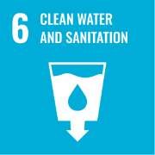 | 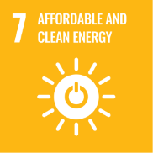 | 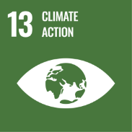 | 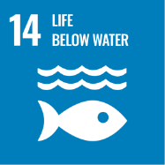 | 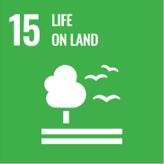

Reporting
Environmental performance is regularly monitored and reported across key parameters such as energy, water, emissions, and waste. Periodic internal reports support management review and tracking of environmental objectives. Statutory reporting requirements are complied with on time, and incidents or deviations are documented and addressed through corrective actions.

Review Mechanism
The Environmental Policy is reviewed annually or as and when required by Top Management to ensure its continued relevance and effectiveness. The review considers applicable legal requirements, environmental performance, audit results, and changes in operational activities. Necessary updates to objectives and actions are approved by Top Management and communicated across the organization for effective implementation.

Approved by:

Employee Acknowledgement
I confirm that I have received, read, and understood the Environmental Responsibility Policy of the organization. I acknowledge my responsibility to comply with all applicable environmental requirements, procedures, and controls relevant to my role.
I understand that protection of the environment, prevention of pollution, efficient use of resources, and compliance with environmental regulations are integral parts of my job responsibilities.
I agree to actively participate in environmental initiatives, follow good environmental practices, and report any environmental incidents, non-compliances, or risks observed during my work.

Declaration
I hereby acknowledge my commitment to adhere to the Environmental Responsibility Policy and contribute towards the organization’s environmental objectives and sustainability goals.

Employee Name: _________________________
Designation: _____________________________
Department: _____________________________
Date: ___________________________________
Employee Signature: _______________________

